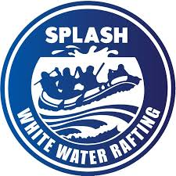

**🌊 Rafting Site Style Guide**

**🎨 Color Palette**

| **Label** | **Hex Code** | **Description** |
| --- | --- | --- |
| **Primary Color** | #505033 | Drab dark brown – for body text and bold accents |
| **Secondary Color** | #264969 | Indigo dye – used for headers and backgrounds |
| **Accent 1 Color** | #CFCFB4 | Pearl – subtle highlight elements and backgrounds |
| **Accent 2 Color** | #B4CDE4 | Columbia blue – links, buttons, and visual pops |

**Color Palette URL:** https://coolors.co/505033-264969-cfcfb4-b4cde4

**🖋️ Typography**

| **Font Label** | **Font Name** | **Usage Description** |
| --- | --- | --- |
| **Heading Font** | Georgia | Used for titles and section headers |
| **Text Font** | Roboto | Used for body copy and paragraphs |